
SRM Institute of Science and Technology
SET B
College of Engineering and Technology
School of Computing
DEPARTMENT OF COMPUTING TECHNOLOGIES
SRM Nagar, Kattankulathur – 603203, Chengalpattu District, Tamilnadu
Academic Year: 2021-2022 (EVEN)
Test: CLAT-1 Date: 4-4-2022
Course Code & Title: 18CSC205J: Operating systems Duration: 1 Period
Year & Sem: II & IV Max. Marks: 25 Marks
Course Outcomes (CO): |  |  |  |  |  |  | At the end of this course, learners will be able to:
CO-1 : |  | Express the fundamental concepts in operating system
Program Outcomes (PO)
1 | 2 |  | 3 | 4 | 5 | 6 |  | 7 | 8 | 9 | 10 | 11 | 12 | PSO
Engineering Knowledge | Problem Analysis |  | Design & Development | Analysis, Design, Research | Modern Tool Usage | Society & Culture |  | Environment & Sustainability | Ethics | Individual & Team Work | Communication | Project Mgt. & Finance | Life Long Learning | PSO - 1 | PSO - 2 | PSO – 3
3 |  |  | 3 |  |  |  |  |  |  |  |  |  |  | 2

Part - A
(5 x 1 = 5 Marks)
Instructions: Answer all
Q. No | Question | Marks | BL | CO | PO | PI Code
1 | When the process issues an I/O request __________  A. It is placed in an I/O queue  B. It is placed in a waiting queue  C. It is placed in the ready queue  D. It is placed in the Job queue | 1 | 1 | 1 | 1 | 1.6.1
2 | Inter process communication can be done through __________.  A. Mails  B. Message  C. System calls  D. Traps | 1 | 1 | 1 | 1 | 1.6.1
3 | Increasing the RAM of a computer typically improves performance because:  A. Virtual memory increases  B. Larger RAMs are faster  C. Fewer page faults occur  D. Fewer segmentation faults occur | 1 | 1 | 1 | 1 | 1.6.1
4 | To access the services of operating system, the interface is provided by the ___________  A. System calls  B. API  C. Library  D. Assembly instructions | 1 | 1 | 1 | 1 | 1.6.1
5 | In UNIX, the return value for the fork system call is _____ for the child process and _____ for the parent process.  - A Negative integer, Zero  - Zero, A Negative integer  - Zero, A nonzero integer  - A nonzero integer, Zero | 1 | 1 | 1 | 1 | 1.6.1
Part – B
(5 x 4 = 20 Marks)
Instructions: Answer any 5
6 | With a neat sketch brief typical process implementation  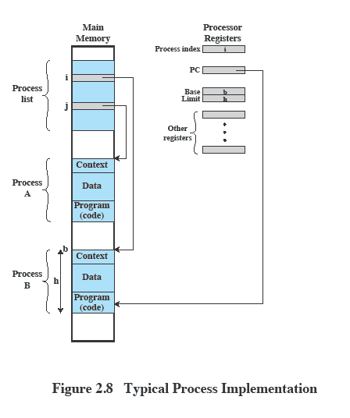 | 4 | 3 | 1 | 2 | 2.6.2
7 | Illustrate the various situations in which the process gets terminated.  - Some operating systems do not allow child to exists if its parent has terminated. If a process terminates, then all its children must also be terminated.  - cascading termination. All children, grandchildren, etc. are terminated.  - The termination is initiated by the operating system.  - The parent process may wait for termination of a child process by using the wait()system call. The call returns status information and the pid of the terminated process  pid = wait(&status);  - If no parent waiting (did not invoke wait()) process is a zombie  - If parent terminated without invoking wait , process is an orphan | 4 | 3 | 1 | 1 | 1.7.1
8 | Explain about cooperating process?  - Independent process cannot affect or be affected by the execution of another process  - Cooperating process can affect or be affected by the execution of another process  - Advantages of process cooperation  - Information sharing  - Computation speed-up  - Modularity  - Convenience | 4 | 2 | 1 | 1 | 1.7.1
9 | Analyze the difference between named pipes and ordinary pipes used in IPC  Named Pipes  named Pipes are more powerful than ordinary pipes  Communication is bidirectional  No parent-child relationship is necessary between the communicating processes  Several processes can use the named pipe for communication  Provided on both UNIX and Windows systems  Ordinary Pipes  Ordinary Pipes allow communication in standard producer-consumer style  Producer writes to one end (the write-end of the pipe)  Consumer reads from the other end (the read-end of the pipe)  Ordinary pipes are therefore unidirectional  Require parent-child relationship between communicating processes  Windows calls these anonymous pipes  See Unix and Windows code samples in textbook | 4 | 3 | 1 | 1 | 1.7.1
10 | Compare threads versus process.  - Processes have two characteristics:  - Resource ownership - process includes a virtual address space to hold the process image  - Scheduling/execution - follows an execution path that may be interleaved with other processes  - These two characteristics are treated independently by the operating system  - The unit of dispatching is referred to as a thread or lightweight process  - The unit of resource ownership is referred to as a process or task  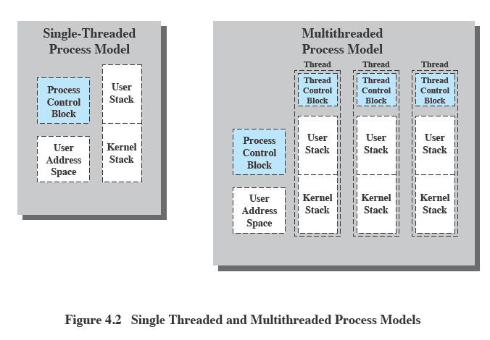 | 4 | 4 | 1 | 2 | 2.6.4
11 | Summarize the various functions of process control block  Process Control Block (PCB)  Information associated with each process  (also called task control block)  - Process state – running, waiting, etc  - Program counter – location of instruction to next execute  - CPU registers – contents of all process-centric registers  - CPU scheduling information- priorities, scheduling queue pointers  - Memory-management information – memory allocated to the process  - Accounting information – CPU used, clock time elapsed since start, time limits  - I/O status information – I/O devices allocated to process, list of open files | 4 | 2 | 1 | 2 | 2.6.2

